**Delivery time -> Predict delivery time using sorting time**

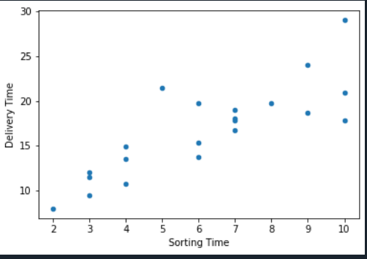

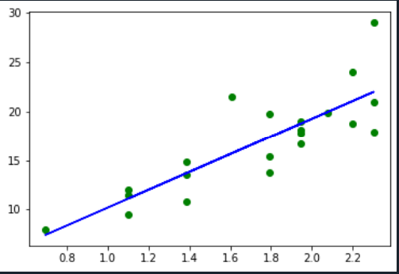

**Mean square error: 7.47 Root mean square: 2.733**